# **PRACTICE REPORT**

# **WEB PROGRAMMING LAB WORKS**

# **MODULE 2**

# **“HTML (*Hypertext Markup Language*) ADVANCED”**



**Assembled by:**

# **ONIC AGUSTINO**

# **L200234275**

**X**

**PROGRAM STUDI TEKNIK INFORMATIKA**

**FAKULTAS KOMUNIKASI DAN INFORMATIKA**

**UNIVERSITAS MUHAMMADIYAH SURAKARTA**

**TAHUN 2024/2025**

**PRACTICE**

1. **Attempt 1 (Hyperlink)**

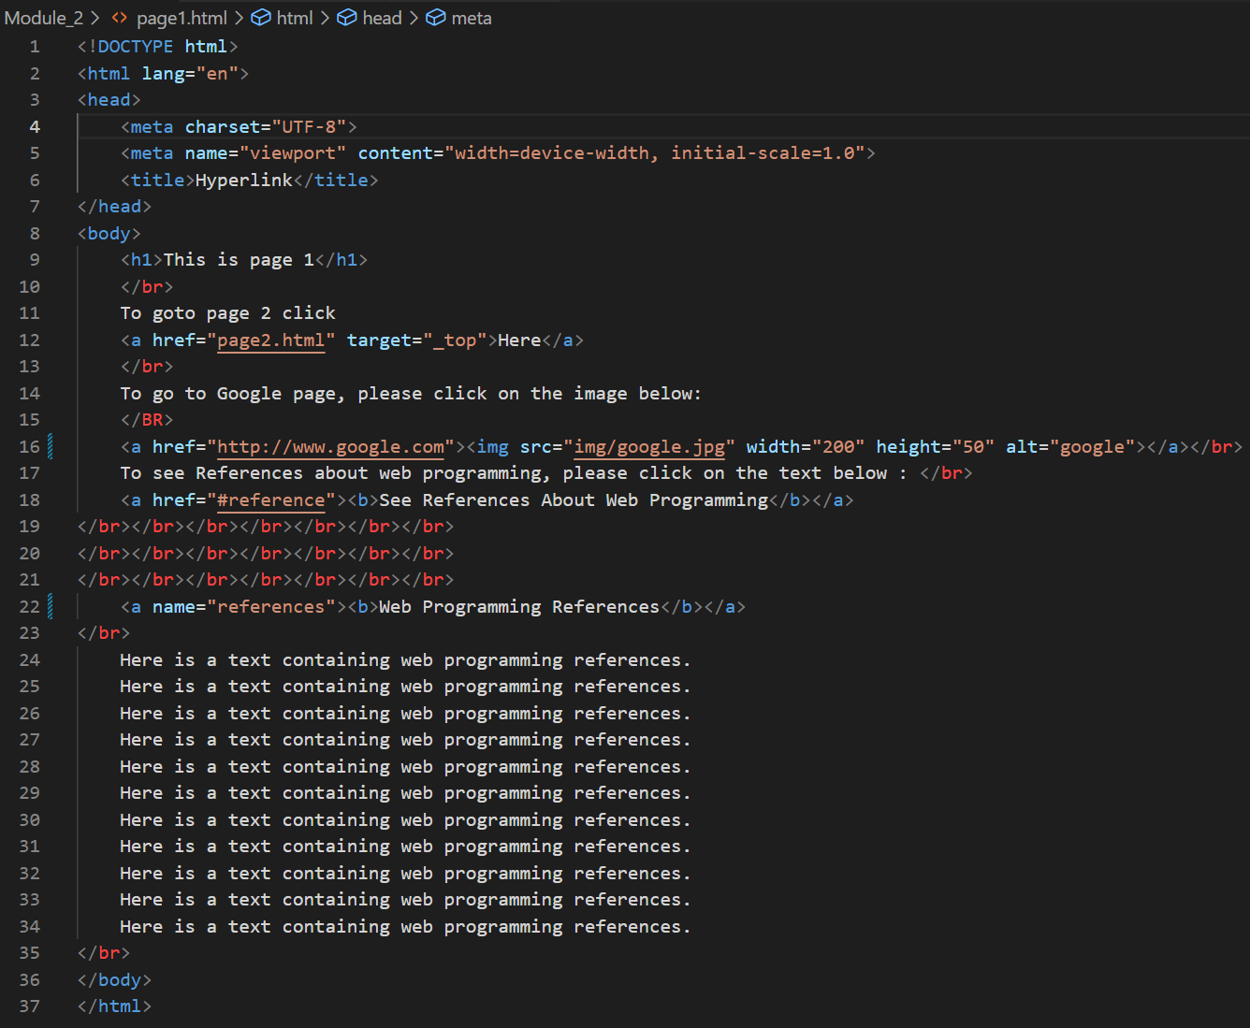

Picture 1.1 The Code.

(Explanation)

This HTML code demonstrates hyperlinks, including internal and external links. It includes an image link to Google and an anchor link for navigation within the page. The anchor target is a reference section for web programming.

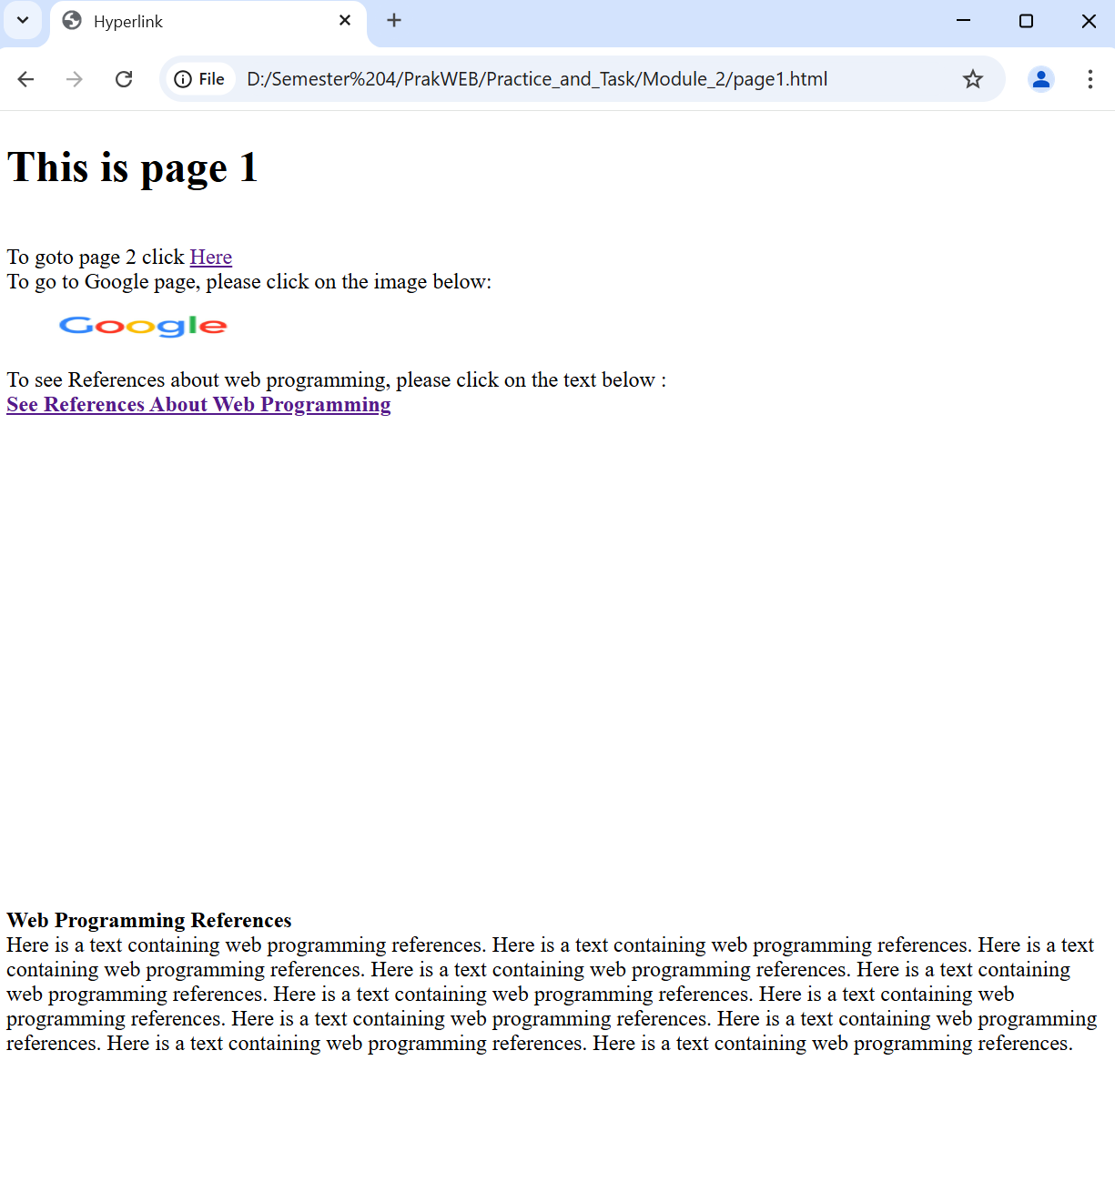

Picture 1.2 The Output.

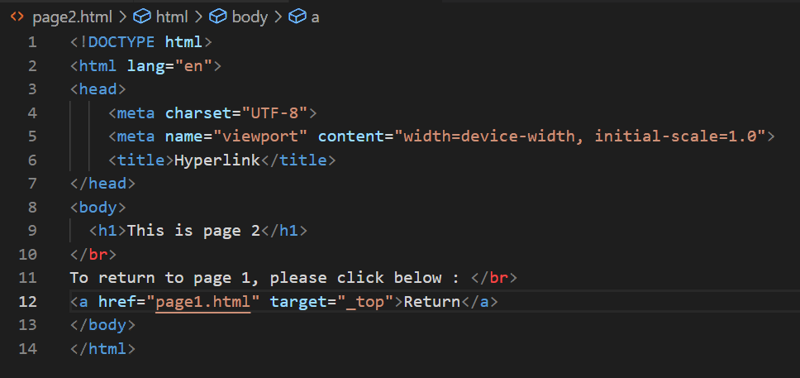

Picture 1.3 The Code.

(Explanation)

This HTML code creates **Page 2** with a hyperlink to return to **Page 1**.

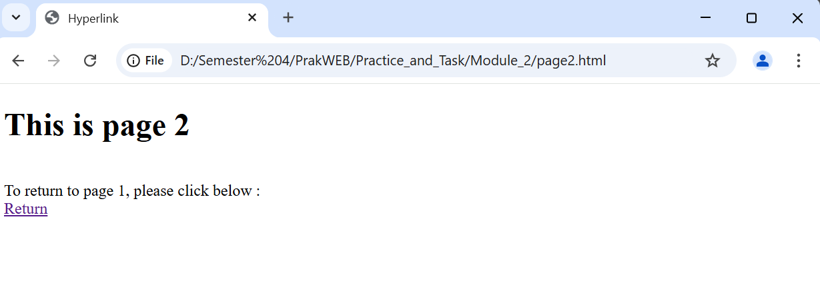

Picture 1.4 The Output.

1. **Attempt 2 (Form)**

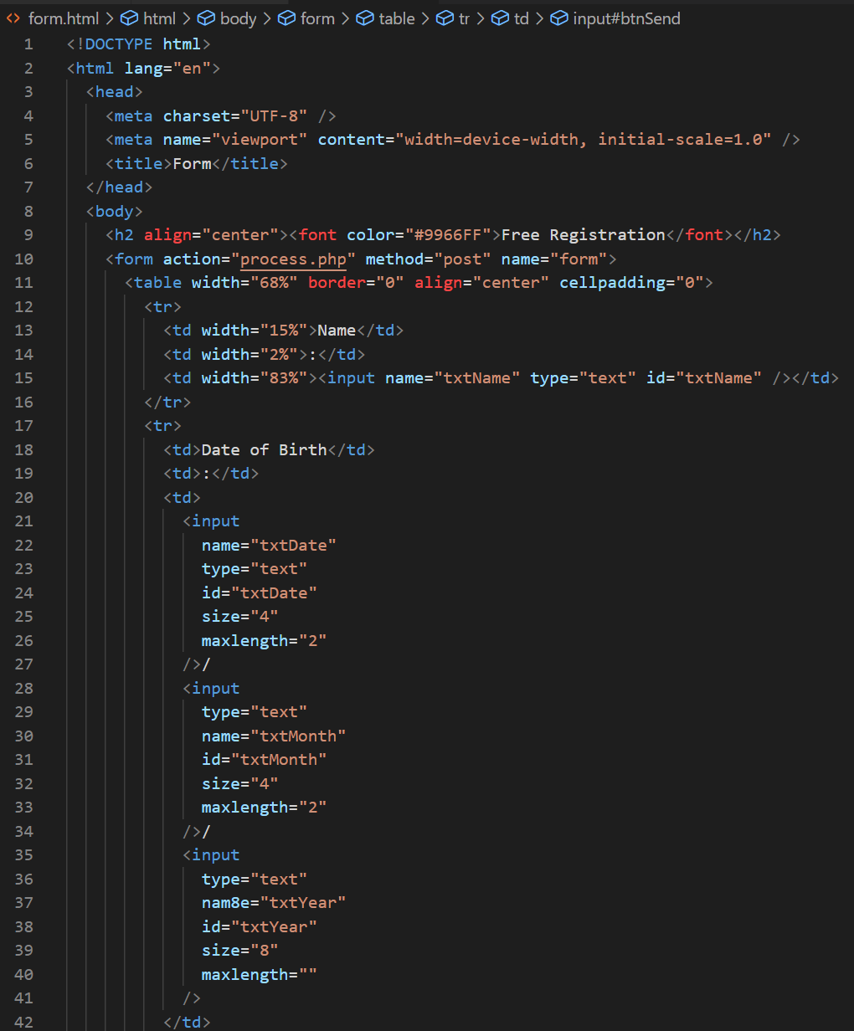

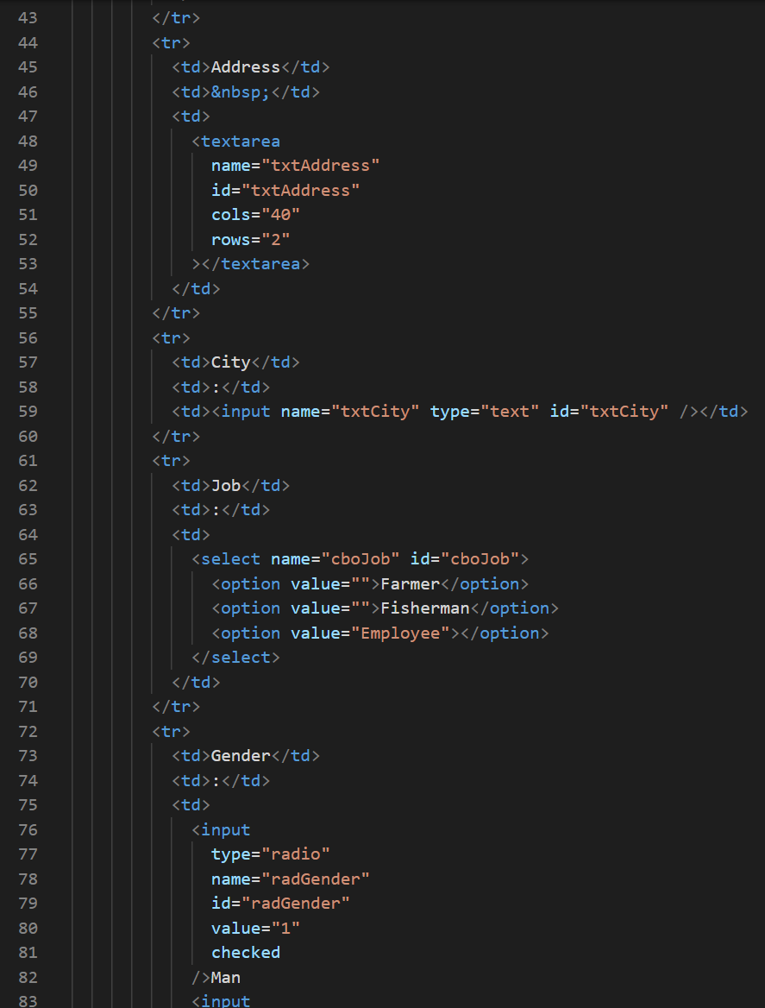

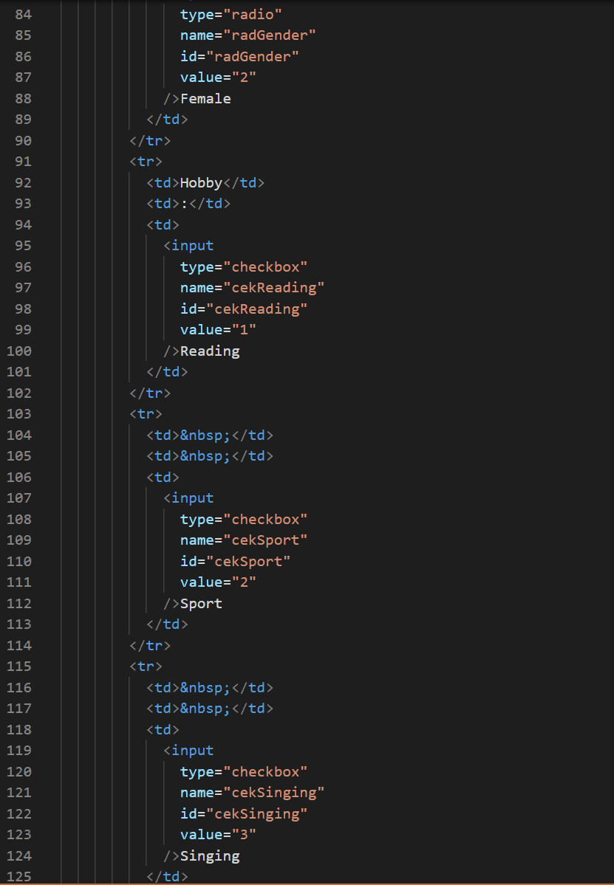

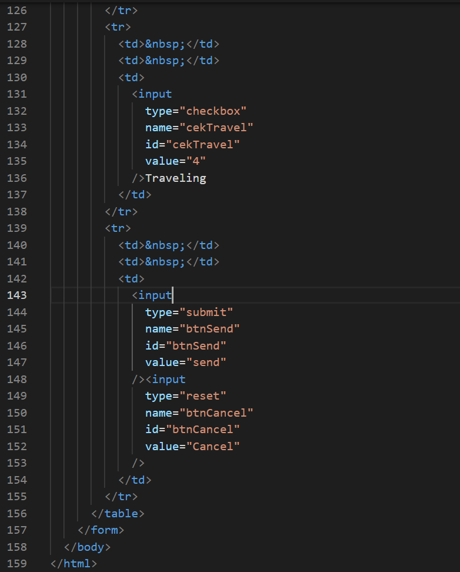

Picture 2.1 The Code.

(Explanation)

This HTML form collects user data, including name, date of birth, address, city, job, gender, and hobbies. It uses <input> fields for text, radio buttons for gender selection, checkboxes for hobbies, and a dropdown for job selection. The form action sends data to process.php using the POST method. The submit and reset buttons allow users to send or clear the form. Some errors exist, such as a misspelled attribute name and an empty job option.

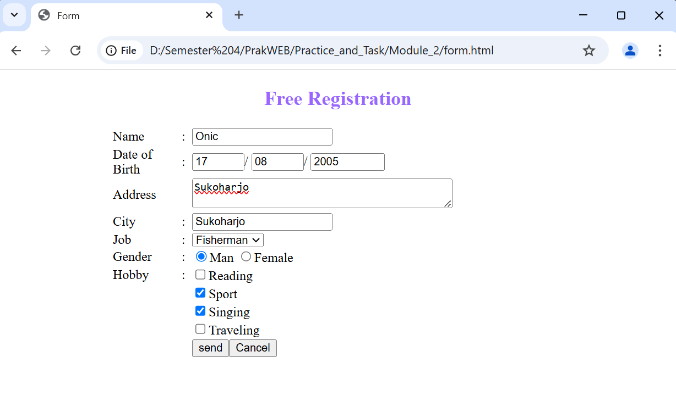

Picture 2.2 The Output

1. **Experiment 3 (Animation)**

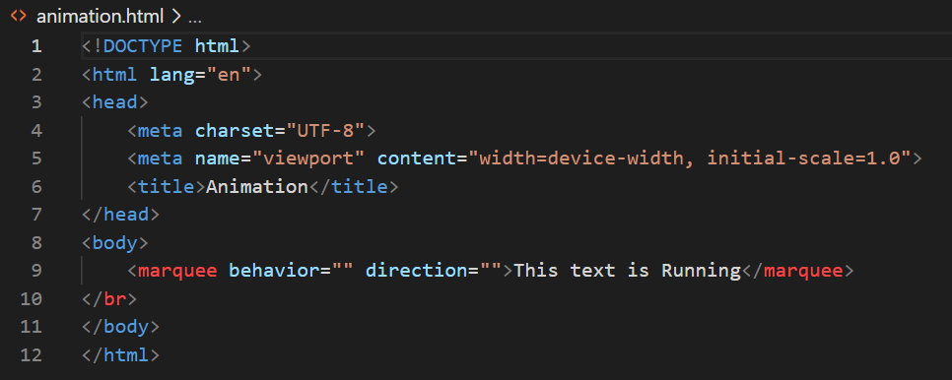

Picture 3.1 The Code.

(Explanation)

This HTML code creates a simple web page with a moving text animation. The <marquee> tag makes the text scroll across the screen. The <br> tag adds spacing below the marquee.

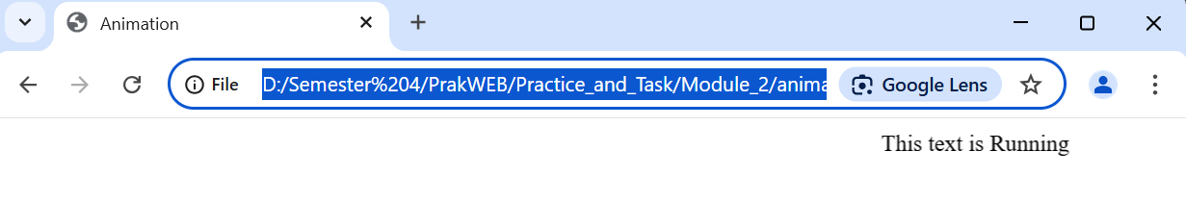

3.2 The Output.

**ASSIGNMENT**

1. **Write an HTML script to create a running image where the images ia a hyoerlink to the address [www.google.com](http://www.google.com). (image size 100 x 50 pixels, and target hyperlink in the same window)**

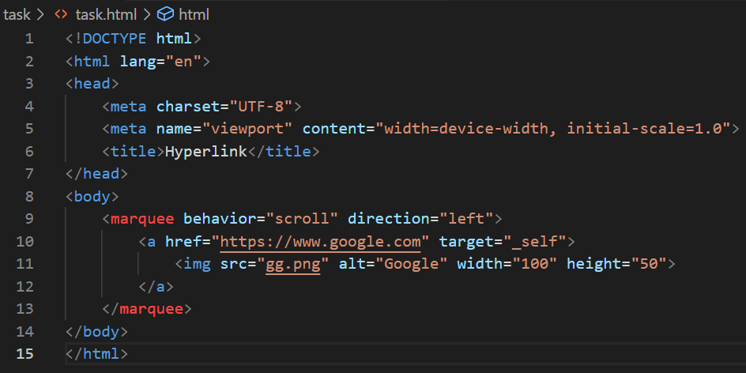

Picture Task.1 The Code.

(Explanation)

This HTML code creates a scrolling hyperlink using the <marquee> tag. Inside the marquee, an <a> tag links to Google, opening in the same tab (target="_self"). The <img> tag displays an image (gg.png) as the clickable link. The behavior="scroll" and direction="left" attributes make the image move from right to left.

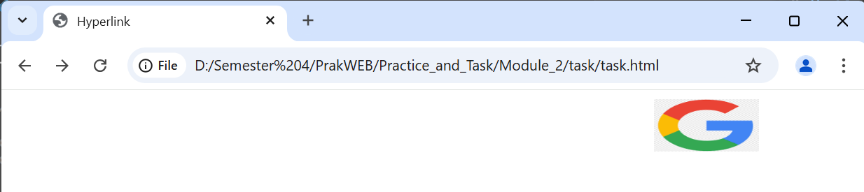

Picture Task.2 The Output

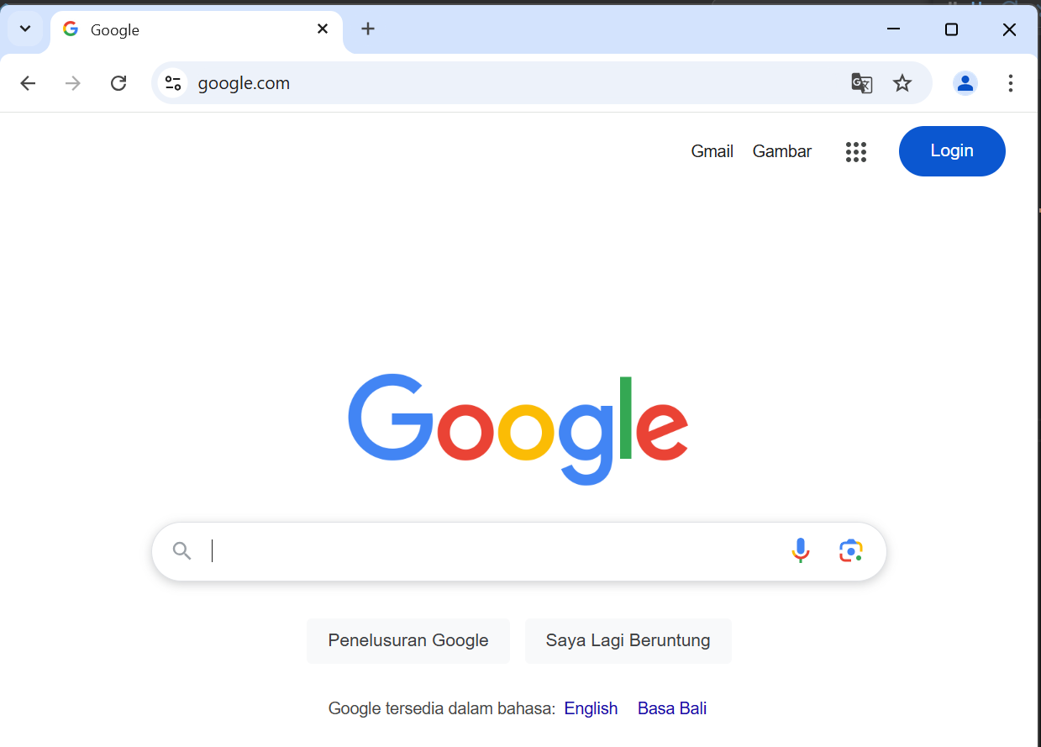

Picture Task.3 The Ouput after click image google.

1. **Explain the function of the following tags and attributes**

|  |  |  |
| --- | --- | --- |
| No | Tag/Attribute | Description |
| 1 | <a href='halaman2.html'> | Links to halaman2.html, which is another page within the same website. |
| 2 | <a href='http://www.google.com'> | Redirects users to Google, an external website. |
| 3 | <a href='referensi'> | Creates a hyperlink to an element or section named "referensi" within the same page. |
| 4 | target='_blank' | Opens the hyperlink in a separate browser tab or window. |
| 5 | <input type='checkbox'> | Displays a checkbox that can be toggled on or off. |
| 6 | name='cekSing' | Assigns an identifier to an input field, typically used in forms. |
| 7 | <input type='text'> | Creates a text field for user input, limited to a single line. |
| 8 | id='txtKota' | Provides a unique identifier for an element, used in JavaScript or CSS. |
| 9 | maxlength='20' | Restricts input fields to a maximum of 20 characters. |
| 10 | <textarea></textarea> | Generates a multi-line input box, such as for user comments. |
| 11 | cols='20' | Defines the width of a textarea in terms of character columns. |
| 12 | &nbsp; | Inserts a space character that prevents automatic line breaks. |
| 13 | <marquee>...</marquee> | Moves text or images across the screen (outdated, not recommended). |
| 14 | <blink>...</blink> | Causes text to flash on and off, though this is no longer supported by most browsers. |